DBMS – PRODUCT AND CATEGORY MANAGEMENT
PURPLE COMPANY – E-COMMERCE MANAGEMENT DATABASE SYSTEM

1. DATABASE DESIGN
1.1 CATEGORY TABLE

Attribute | Description
Category_ID | Unique category ID
Category_Name | Category name

1.2 PRODUCT TABLE

Attribute | Description
Product_ID | Unique product ID
Product_Name | Product name
Price | Product price
Stock | Available stock
Category_ID | Category ID

2. PRIMARY AND FOREIGN KEY RELATIONSHIP
PurpleCategory → PurpleProduct
- PurpleCategory.Category_ID → Primary Key
- PurpleProduct.Product_ID → Primary Key
- PurpleProduct.Category_ID → Foreign Key referencing PurpleCategory.Category_ID
- Relationship: One-to-Many (1:M)

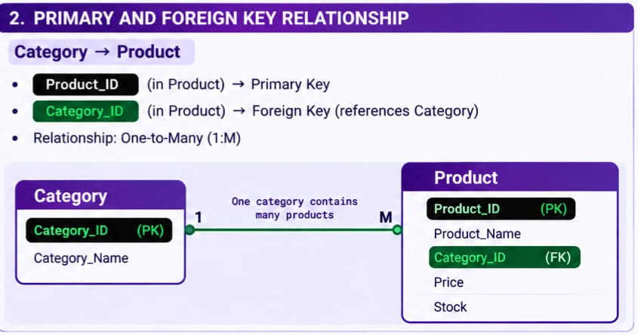
3. TABLE CREATION
3.1 CREATE CATEGORY TABLE
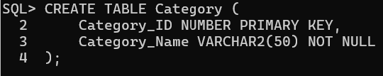
3.2 CREATE PRODUCT TABLE
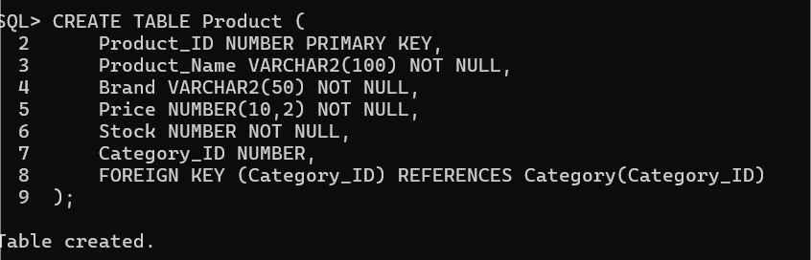
4. DATA INSERTION
4.1 CATEGORY RECORDS
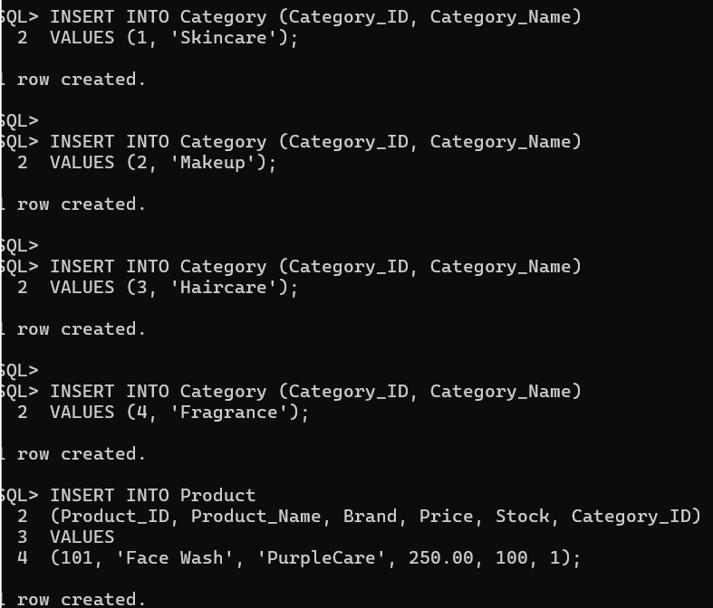
4.2 PRODUCT RECORDS
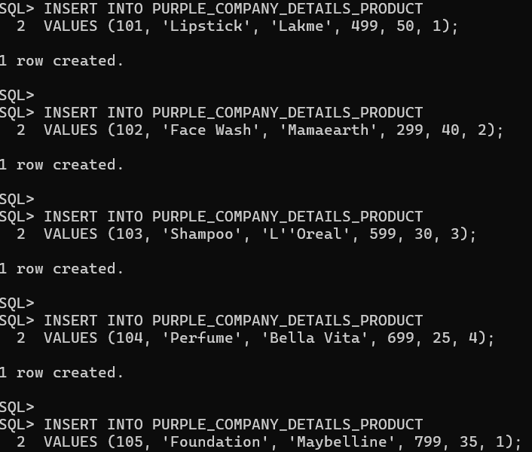
5. DATA RETRIEVAL
5.1 DISPLAY CATEGORY RECORDS
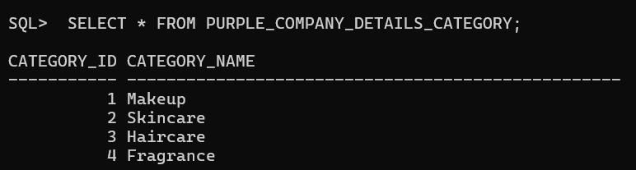

5.2 DISPLAY PRODUCT RECORDS
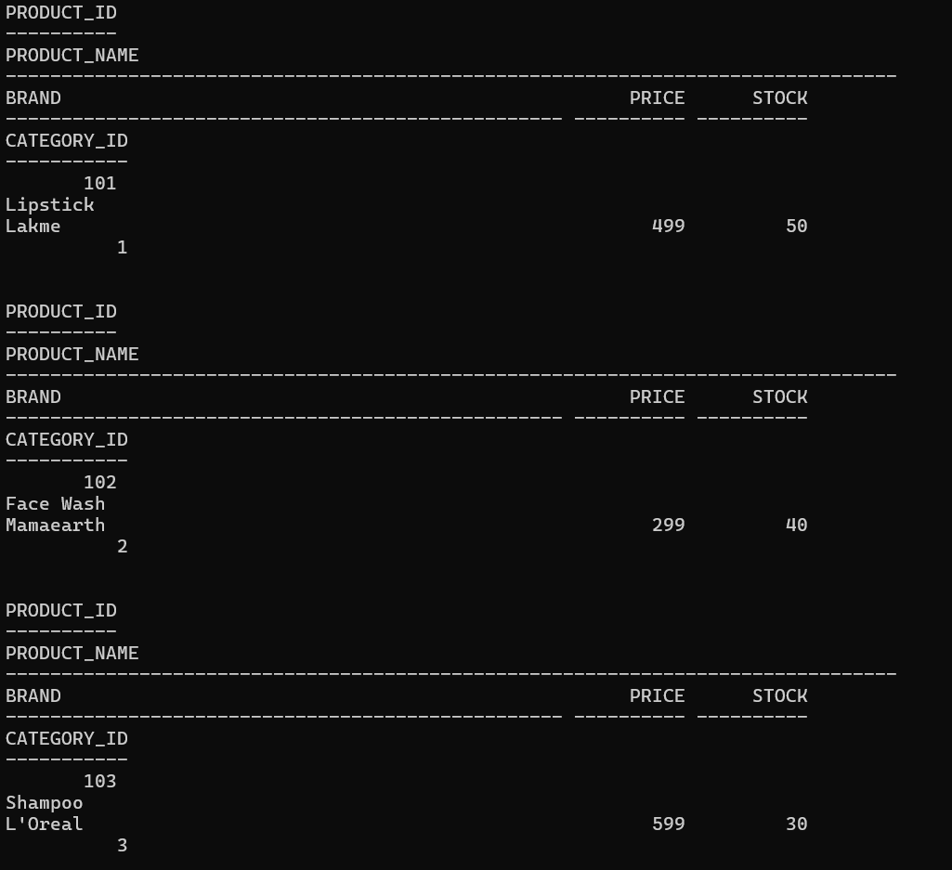
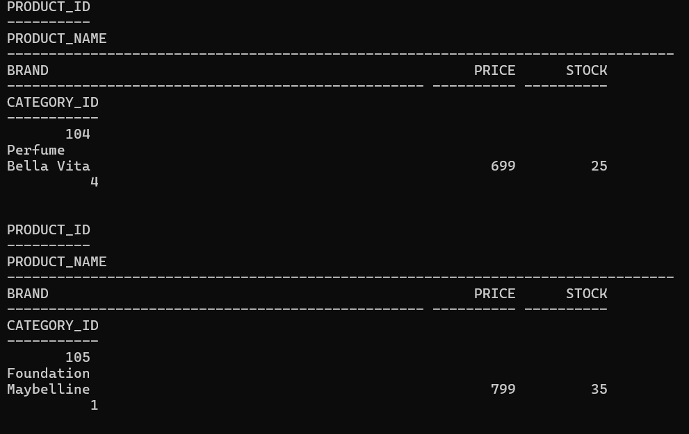

6. PRODUCT UPDATE
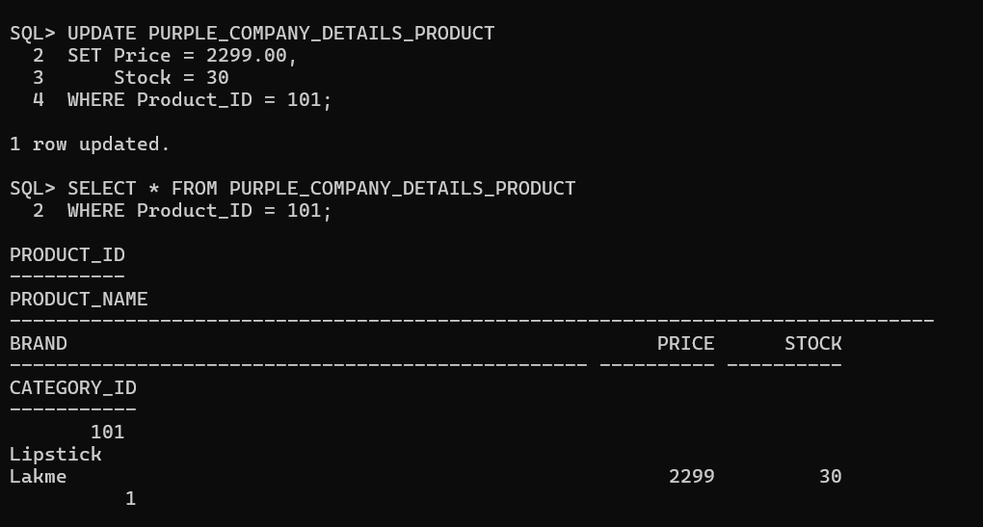
7. PRODUCT DELETION
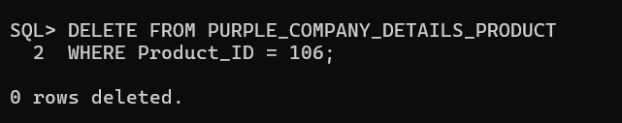

8. CATEGORY UPDATE
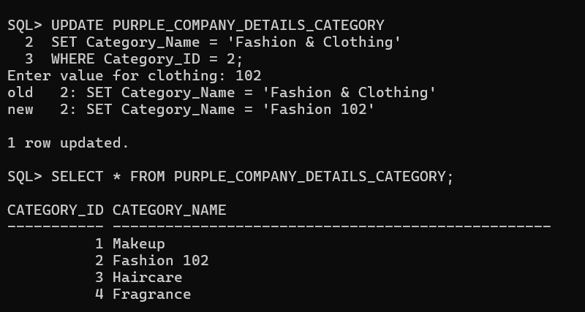
9. CATEGORY-WISE PRODUCT REPORT
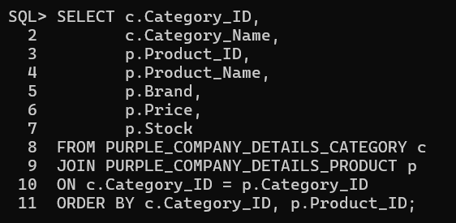
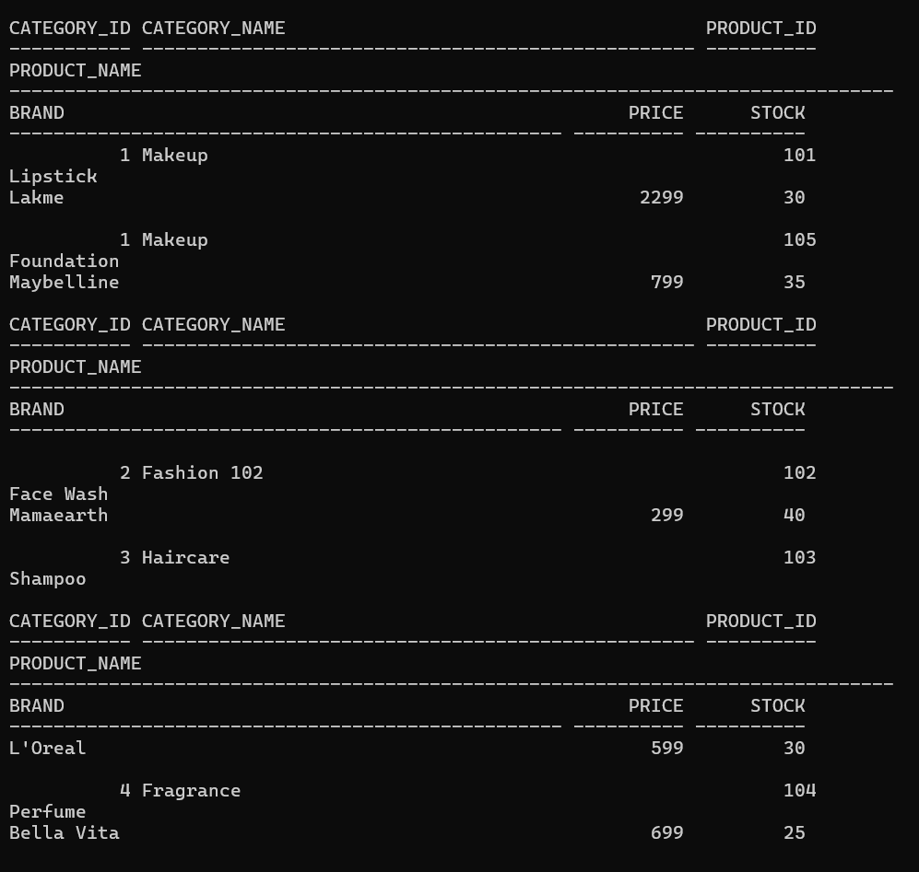
10. CATEGORY-WISE TOTAL PRODUCTS REPORT
